RDS DB Deployement For Django Chat Application with EC2 DB Instance :

1. Decide Your DB Engine
- Choose the DB engine same as your EC2 DB (for smooth migration).
- Supported: MySQL, PostgreSQL, MariaDB, Oracle, SQL Server, Amazon Aurora.
- MySQL 8.0.43

2. Open the RDS Console
- Sign in to AWS Management Console.
- Navigate to RDS → Databases → Create database.

3. Select Database Creation Method
- Standard Create → gives full configuration options.
- Easy Create → uses AWS defaults (not recommended for production).
Choose Standard Create.

4. Select Engine
- Choose your engine (e.g., MySQL).
- Choose version (MySQL 8.0.43).
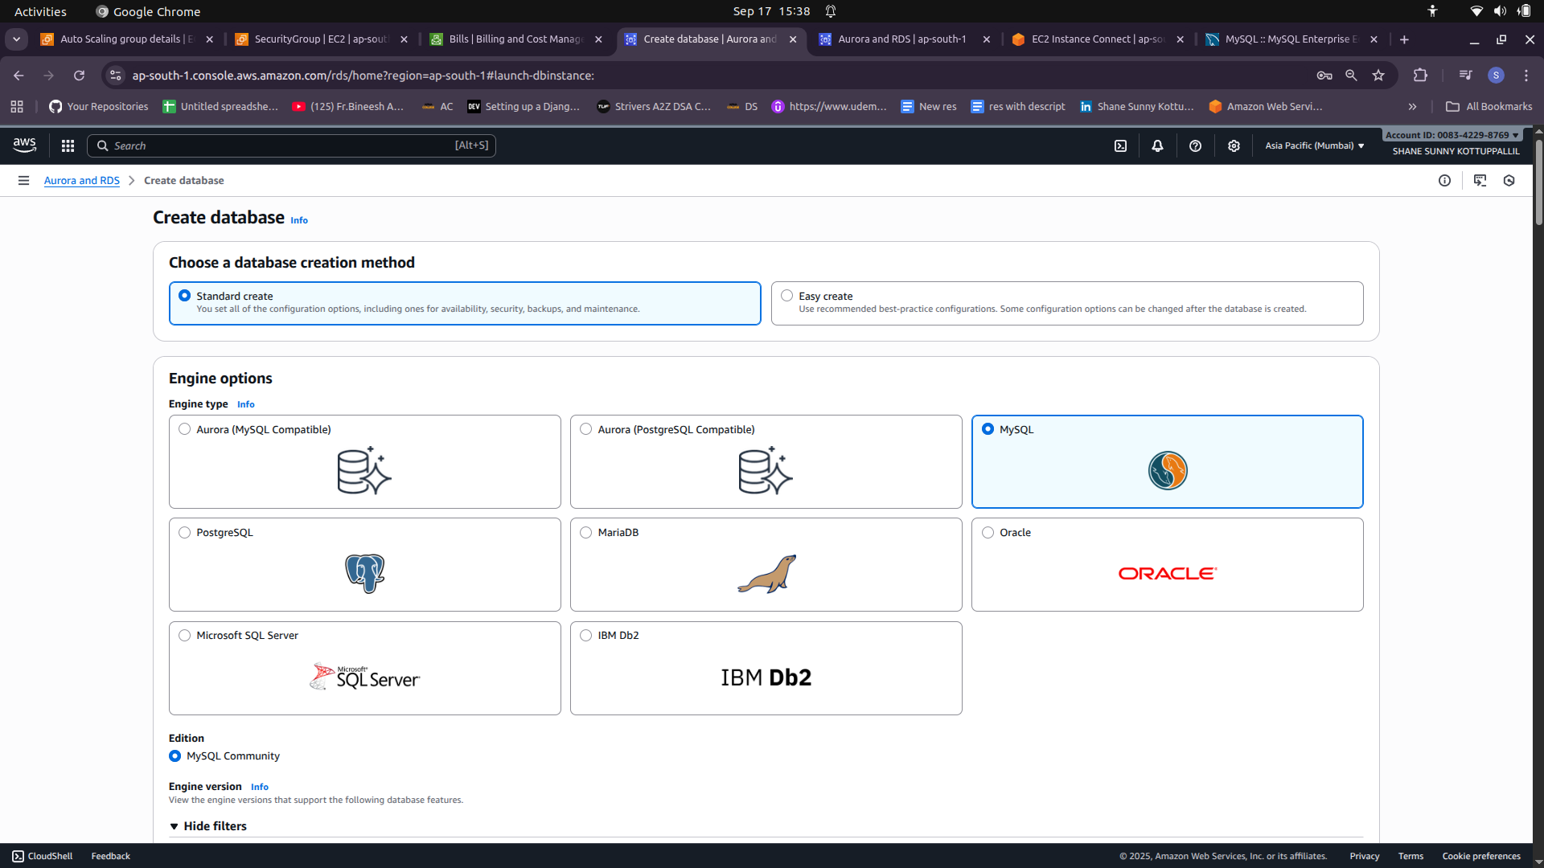

5. Choose Deployment Type
- Production (Multi-AZ) → for high availability.
- Dev/Test → cheaper, no failover. Go with Dev/Test Multi-AZ.
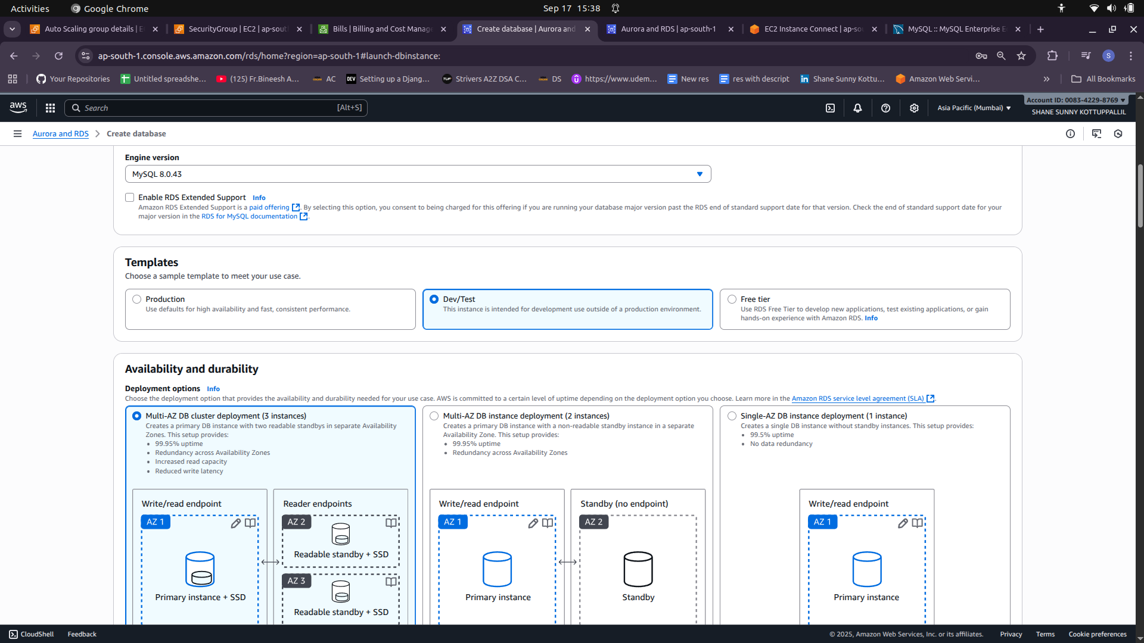

6. Set DB Details
- DB identifier: , ChatDB.
- Master username: root..
- Master password: enter and confirm.
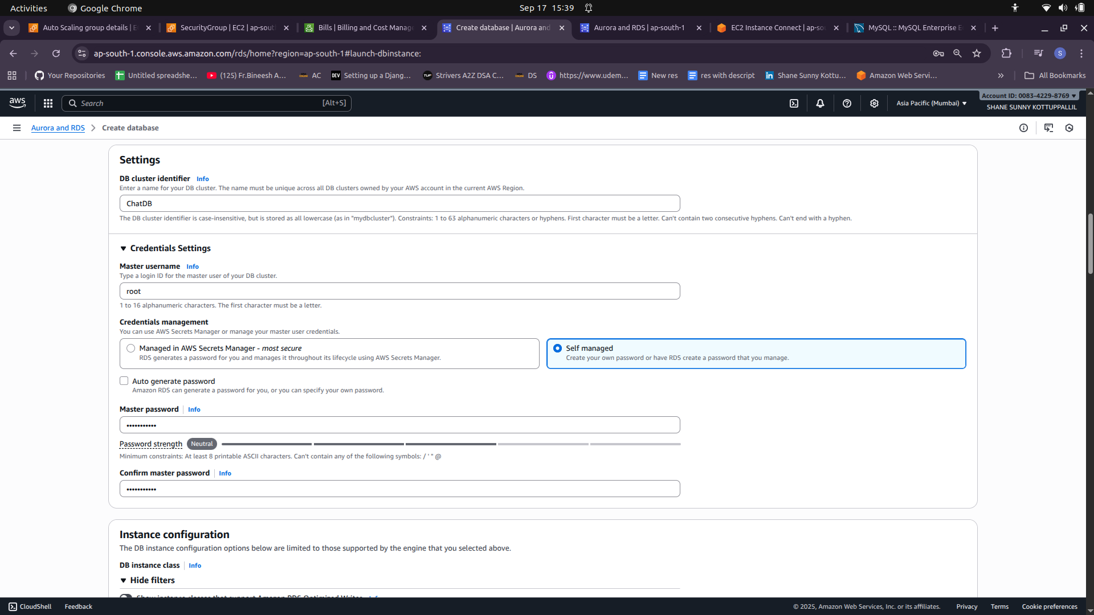

7. Choose Instance Size
- DB instance class = CPU + memory.
- For small apps: db.t3.medium or db.t3.small.
- For larger: db.m5.large or above.

8. Configure Storage
- Default: General Purpose SSD (gp3).
- Allocate storage (20–100 GB to start).
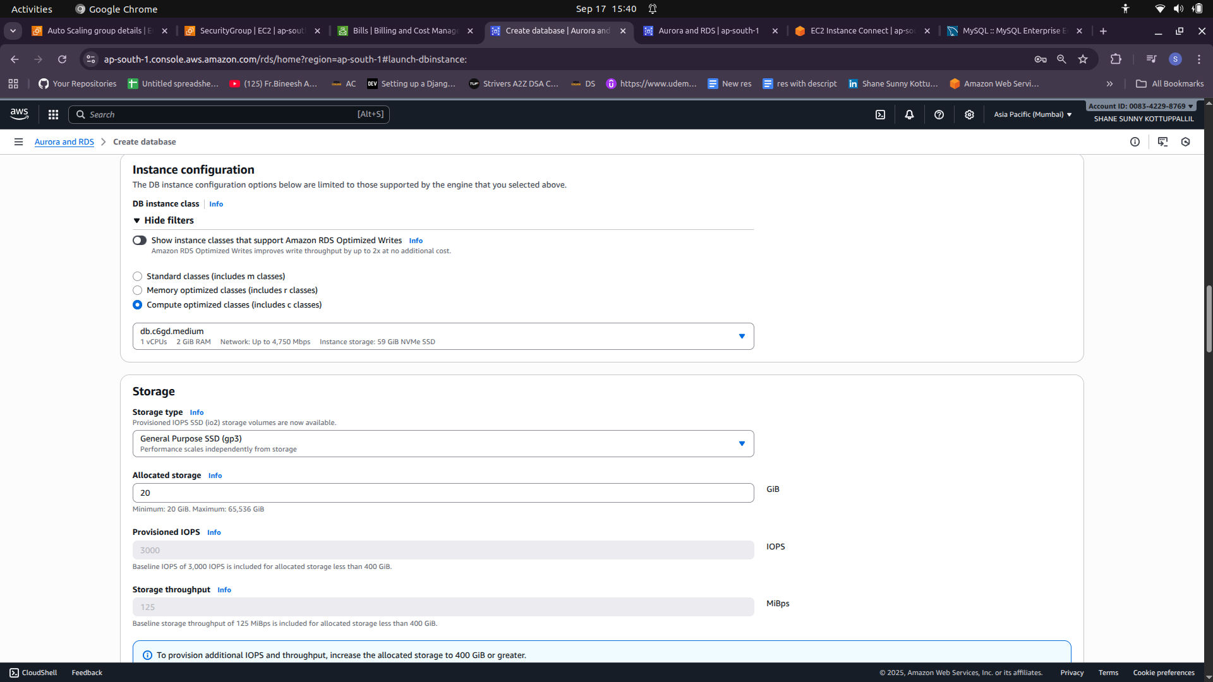

9. Networking & Connectivity
- VPC: Select same VPC as your EC2 instances.
- Subnets: Private subnets (recommended).
- Public access: Set to No (only accessible inside VPC).
- VPC Security Groups:
  - Add inbound rule → allow port 3306 (MySQL) from your App Server SG.
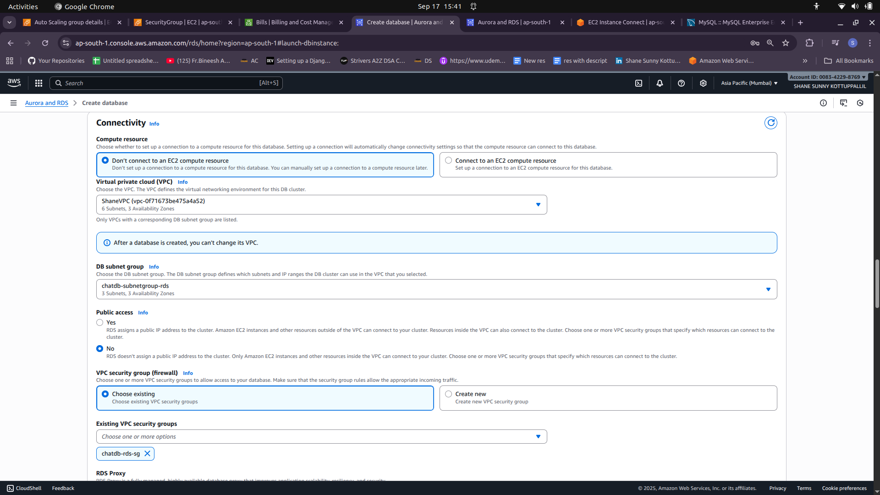

10. Additional Settings
- Database name: Provide your DB name (e.g., myappdb).
- Backup: Enable automated backups (daily, 7–35 days retention).
- Encryption: Enable at rest (KMS).
- Monitoring: Enable Enhanced Monitoring if needed.
- Maintenance window: Pick a low-traffic time.

11. Launch
- Review all settings.
- Click Create Database.
- It will take a few minutes (5–10 mins)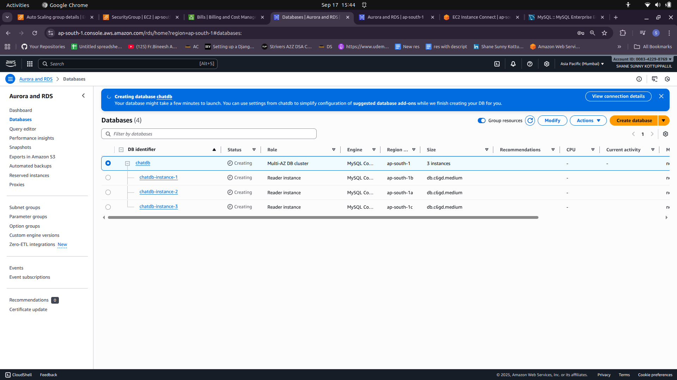 to be “Available”.

‘

Update Environment Variables
DB_NAME=fundoodb
DB_USER=****
DB_PASSWORD=****
DB_HOST=chatdb.c************************
DB_PORT=3306

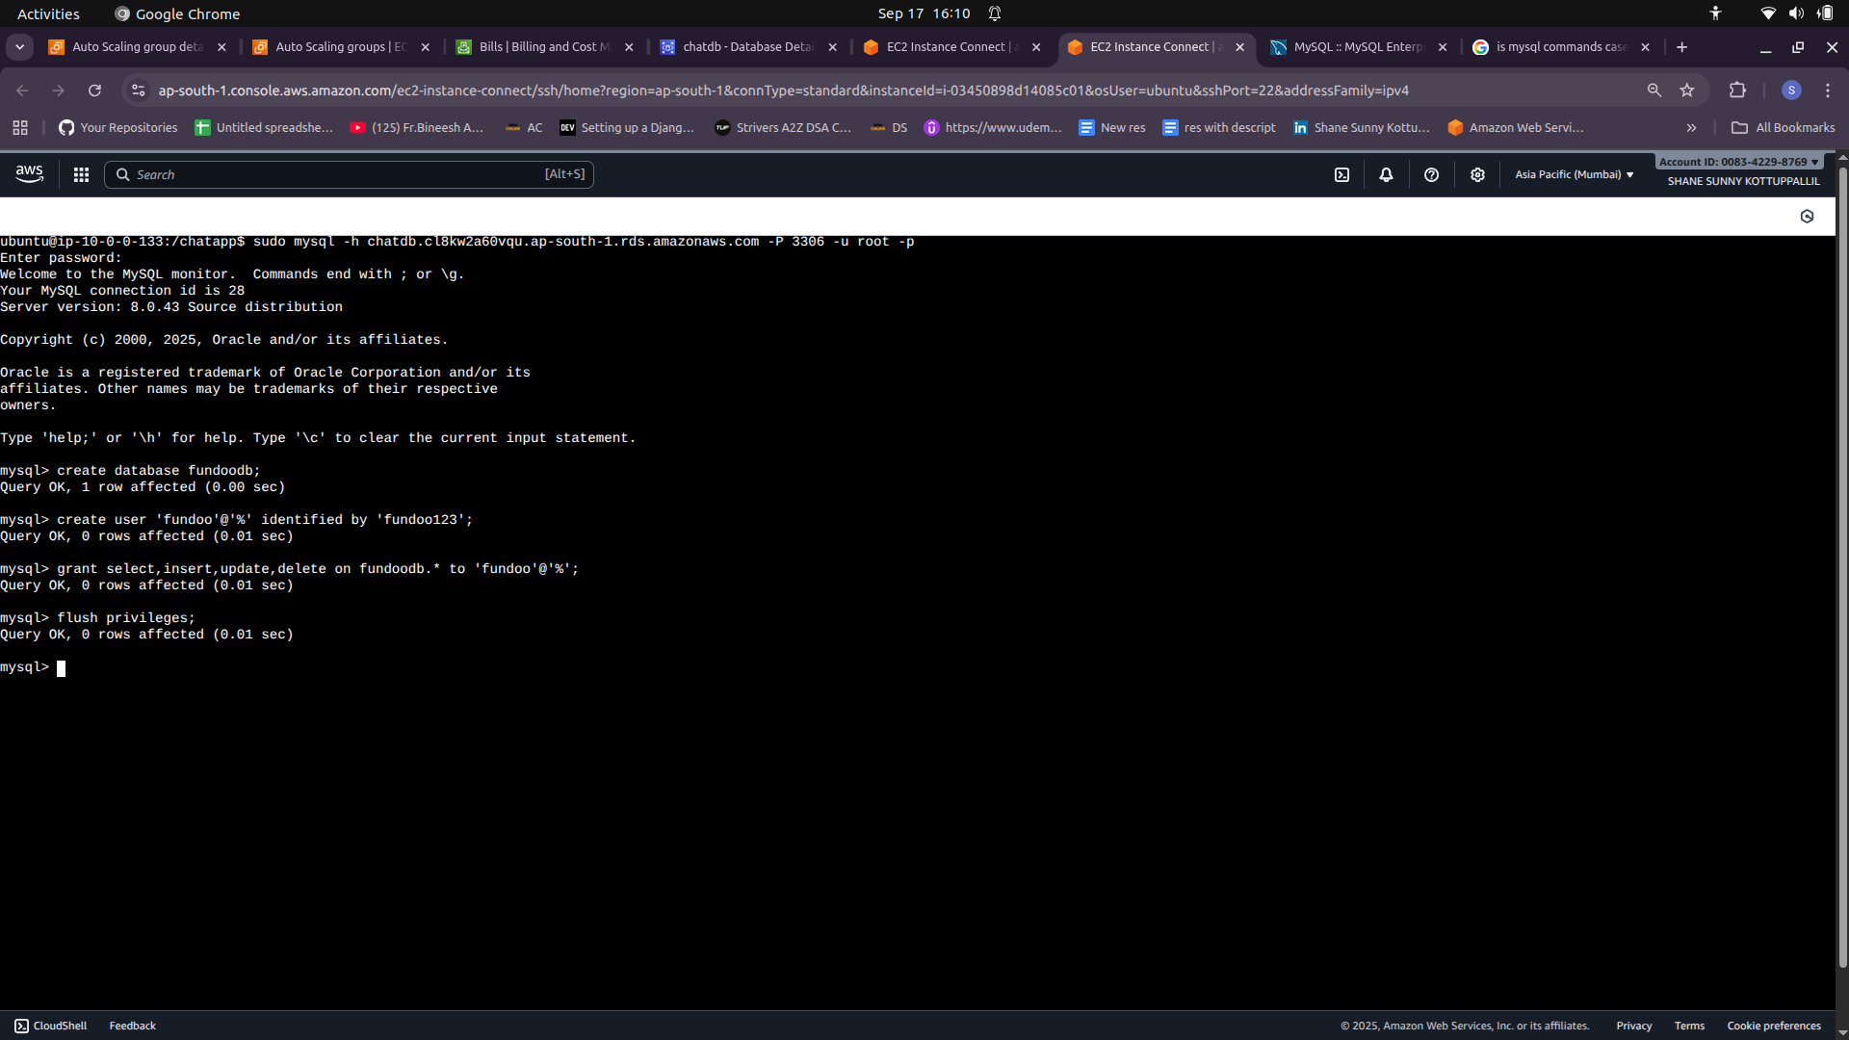

On ChatAPP EC2
source .venv/bin/activate
set -a; source /chatapp/.env;set +a
python3 fundoo/manage.py migrate

sudo systemctl daemon-reload
sudo systemctl restart fundoo-gunicorn

Create new ChatAppAMI and update launch template.
Update Launch Template Version on ASG.

